Preserflo Microshunt
This booklet aims to give you information about your glaucoma surgery (Preserflo Microshunt)
What is Glaucoma?
Glaucoma is a condition of the eye where increased pressure within the eye causes damage to the nerve that allows you to see (optic nerve).This can then lead to some loss of vision. You may not know that you have glaucoma until you have lost a lot of your sight, as there are usually no known early warning symptoms.
Unfortunately drops or glaucoma surgery cannot restore vision that has already been lost. The aim of treatment is to reduce the pressure in the eye to prevent or slow down further damage to the optic nerve and so protect your vision from getting worse.
What is a PreserFlo Microshunt?
The Preserflo is an 8 millimetre long tube that is inserted into the eye to help lower eye pressure in glaucoma and reduce the need for medication. It is made of a synthetic and biocompatible material called SIBS.
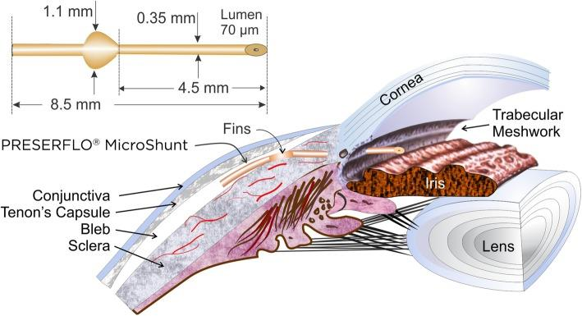
The Preserflo will not cause an allergic reaction, won’t be rejected by the body and will not disappear or disintegrate with time. As it is not metallic, it will not set off airport scanners and is safe if you need to have an MRI or CT scan.
Why do I need it?
The Preserflo Microshunt is aiming to reduce the pressure inside the eye and therefore prevent or slow down further damage to the optic nerve. It will not cure your glaucoma, reverse any damage already caused by glaucoma, or bring back any lost vision.
How does it work?
Glaucoma can cause a build-up of fluid pressure inside the eye. This build- up of fluid pressure is caused by a blockage of the natural drainage channel of the eye. This pressure can damage the optic nerve which carries images from the eye to the brain affecting your vision. The fluid produced inside your eye is called aqueous humour.
Like Trabeculectomy surgery (the traditional Glaucoma surgery), the Preserflo MicroShunt drains fluid from inside the eye to outside, under a thin skin-like membrane covering the white of the eye called conjunctiva. The fluid is drained and pooled under the conjunctiva forming a ‘bleb’. This bleb will stay as long as the fluid is draining.
Your eye surgeon may combine this operation with a cataract operation. Please see the cataract surgery leaflet for further information.
Is the surgery guaranteed to work?
A three-year outcome study has reported a 60% fall in the eye pressure as well as a significant reduction in the number of eye drops a patients needs to take. We currently do not have long-term studies on the device.
Are there alternatives to surgery?
Generally speaking, there are three ways to lower the pressure inside the eye on a long-term basis: eye drops, lasers and surgery.
You may already be using eye drops, but they did not lower the eye pressure enough, you are getting side-effects, or you find it difficult to use the drops. The surgery is used when eye drops and lasers have not worked or are not suitable.
The traditional surgery is called trabeculectomy. The surgeon creates a small cut through the white of the eye (sclera) to allow the fluid to drain into a blister or 'bleb'. The fluid is then reabsorbed back into your bloodstream.
The Preserflo technique that is being offered to you is a new technique. We are offering it to you because it is less invasive than the traditional Trabeculectomy surgery with less recovery time. It also has similar success rate in selected cases after 3 years.
The success rate in reducing the eye pressure by 50% with Preserflo varies between 80% to 90% after 3 years. However we don’t have long term studies showing the success rate after this time point.
What if I don’t want surgery?
You may be suitable for a laser procedure, or you may need more eye drops. However, this may not control your Glaucoma and your vision may continue to get worse.
Preparing for the operation
Please continue to use any eye drops and tablets for your glaucoma as prescribed, unless directed otherwise by your ophthalmologist.
If you take any blood thinning medication (e.g. Warfarin) or have had bleeding problems in the past please discuss this with your ophthalmologist before surgery
Before your operation you will be asked to attend a pre-operative assessment appointment to check you are fit for the procedure and anaesthetic.
What happens at the time of surgery?
The operation is usually performed under a local anaesthetic, meaning that you are awake but your eye is numb so you will not feel anything. Your eye will be numbed with eye drops and then a small injection will be given around your eye. The injection may cause a pressure sensation and brief discomfort. The local anaesthetic takes several hours to wear off and may affect your vision during this time.
You can ask for a sedative drug or a general anaesthetic so that you are fully asleep during the operation
An anti-scarring medication called mitomycin C will be applied to improve the long term success of the surgery. The thin skin-like membrane covering the white of your eye (conjunctiva) will be opened and the MicroShunt is inserted inside your eye. The conjunctiva will be closed with one or two stitches. These stitches may either be removed later in clinic or, in some cases, dissolve by themselves. The surgery is likely to take no more than 35 – 45 minutes.
What happens after the operation?
You can go home when you feel ready. Your eye will be covered by a protective plastic shield which you can take off the morning after surgery. You don’t need to put drops in your eye until after the shield has been taken off.
The morning after your operation you can take the shield off and gently bathe the eye with the solution provided by the nurse. You can then start the post-operative eye drops.
We will usually see you in the eye clinic one day, one week after your operation and again a month later. We may also need to see you on frequent basis during the next 3 months after the surgery.
What about my medication?
If you are using drops in the other eye you should continue to do so unless told otherwise
Please stop your normal glaucoma drops in the operated eye so we can assess the effect of the PreserFlo Microshunt. You may be asked to restart the drops later, depending on the pressure in your eye after the operation.
You will need to use two different drops in your operated eye to help it recover from the surgery. These are an antibiotic and a steroid. You will need to use these for about 3 months after your surgery.
What are the risks and possible complications of surgery?
Serious complications are uncommon. You could have a small amount of bleeding inside your eye. If this happens, your vision could be blurred for few weeks.
The effect of the MicroShunt may wear off with time. This is most often due to scarring around the MicroShunt. We do not have enough data to suggest the likelihood of this with Preserflo but we know that it can happen in up to 40% of cases after 5 years in Trabeculectomy surgery.
We can usually try to remove the scarring around the Preserflo by doing a procedure called Needling. However, this further procedure is not guaranteed to be successful if you have dense scarring. If this happens, you will need to restart your glaucoma medications or have further procedures to control your eye pressure, which would usually be an aqueous shunt.
There is a very rare life-long risk of infection after MicroShunt surgery due to the creation of a bleb, which in very rare cases may cause blindness. There is also a small risk that the shunt might move from its location or become exposed and need to be fixed by doing another surgery.
The is a low risk of low pressure after Preserflow surgery, which is less than that after Trabeculectomy (about 15 percent of cases) and if that happens, you may need another surgery to fix this.
There is also a very low risk of losing the vision if bleeding, infection or retinal detachment happen
How should I look after my eye after surgery?
• You must not rub or press on the eye after surgery. To help stop this happening while you are asleep, you should wear the plastic shield at night for the first week after surgery.
• You can read, watch TV & use a computer as normal.
• Do not drive until your surgeon says it is OK to do so.
• Most people need 1-2 weeks off work after surgery.
• Keep the eye dry for 2 weeks. This is to reduce the chance of infection.
• Please wear goggles if swimming after complete healing of your surgery (which usually takes about 3 months).
• It is safe to fly after the surgery, however you will need to be seen a number of times by your surgeon in the first 3 months.
In case of any serious concerns, you will need to contact us urgently and attend the eye casualty

